How to Use SyntaxTreeHybrid

Getting Started
Open SyntaxTreeHybrid in your web browser (your instructor will provide the link). You will see four main areas:
Area | Location | What It Does
Top palette bar | Top of screen | Clause and phrase tiles: S, NP, VP, PP, ADJP, ADVP
Canvas | Center | Where your tree diagram appears
Right panel | Right side | “Add Word” input box and Bracket Notation editor
Bottom palette bar | Bottom of screen | Part-of-speech tiles: NOUN, VERB, ADJ, ADV, DET, PREP, etc.

Which Method Should I Use?
SyntaxTreeHybrid gives you two ways to build syntax trees. You can use either one, or mix and match.
 | Drag and Drop | Bracket Notation
Best for | Beginners; visual learners | Speed; experienced users
Pros | Intuitive and visual; you can see the tree take shape as you build it | Much faster once you learn the syntax; easy to copy, paste, and share
Cons | Slower for complex trees; requires more clicks and drags | Steeper learning curve; harder to spot mistakes at first
Recommendation | Start here to understand how trees work | Switch to this once you are comfortable with tree structures
Both methods stay synchronized — if you build a tree by dragging tiles, the bracket notation updates automatically on the right, and vice versa.

Method 1: Drag and Drop

Adding Phrase and Part-of-Speech Tiles
- Find the tile you need on the top palette bar (for phrases like NP, VP, PP, ADJP, ADVP) or the bottom palette bar (for parts of speech like NOUN, VERB, ADJ, ADV, DET, PREP).
- Click and drag the tile from the palette onto the canvas.
- Release the tile where you want it. Do not worry about exact placement — you can move tiles around after dropping them.

Connecting Tiles (Parent to Child)
Once you have tiles on the canvas, you need to connect them to show the tree structure:
- Drag a child tile close to the tile you want to be its parent.
- When the child is close enough, a line will automatically appear connecting the two tiles.
- The child tile will snap into position below its parent.

Changing a Connection
If you connected a tile to the wrong parent:
- Click on the line connecting the two tiles. This removes the connection.
- Now drag the child tile close to the correct parent tile to create a new connection.

Adding Words (Terminal Nodes)
Words go at the bottom of each branch. To add a word:
- Find the “Add Word” input box on the right panel.
- Type your word in the text box (e.g., dogs).
- A preview tile will appear next to the text box.
- Drag the preview tile onto the canvas and drop it near the part-of-speech tile it belongs under (e.g., drag dogs near the NOUN tile).
- The word tile will connect automatically.

Editing Text on a Tile
If you need to change the label on any tile that is already on the canvas:
- Ctrl+click (or Cmd+click on Mac) on the tile you want to edit.
- A text cursor will appear — type the new label.
- Click elsewhere on the canvas to finish editing.

Deleting Tiles
To remove a tile from the canvas:
- Click on the tile to select it (you will see it highlighted).
- Press the Delete key on your keyboard.
- The tile and any lines connected to it will be removed.

Deleting Connection Lines
To remove a line without deleting either tile:
- Click directly on the line connecting two tiles.
- The line will disappear, but both tiles remain on the canvas.
- You can then drag either tile to create a new connection if needed.

Method 2: Bracket Notation

How It Works
Bracket notation lets you type your entire tree as text in the Bracket Notation box on the right side of the screen. The tree diagram appears automatically on the canvas as you type.
Every node in the tree is wrapped in square brackets. Inside the brackets, you write the label first, then its children (which are also in brackets).
Example: To diagram the sentence “Dogs bark,” type:
[S [NP [N Dogs]] [VP [V bark]]]
This produces the following tree:
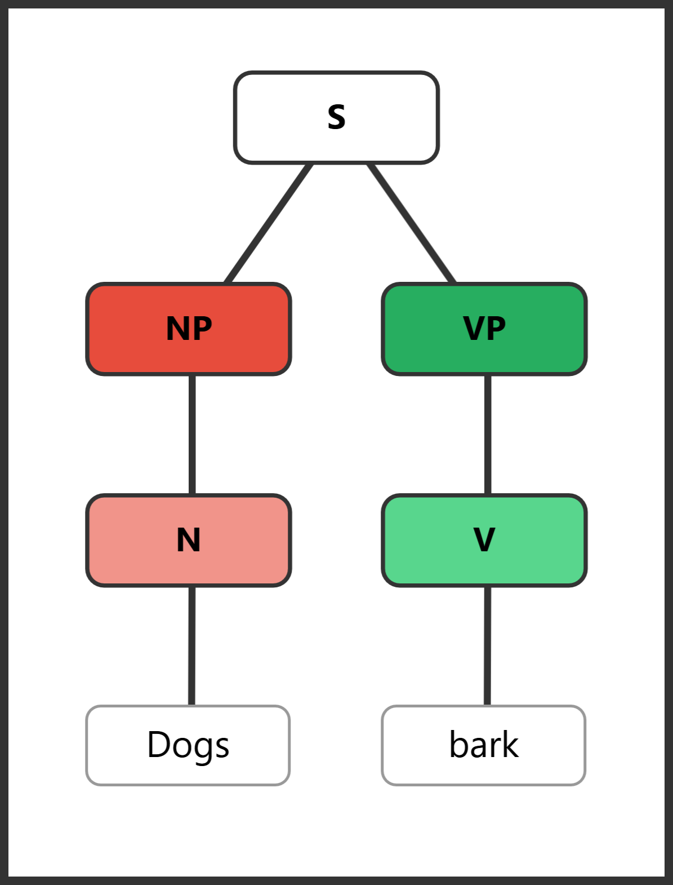
Reading from outside in:
- [S ...] — the whole thing is a Sentence
- [NP [N Dogs]] — the subject is a Noun Phrase containing a Noun (Dogs)
- [VP [V bark]] — the predicate is a Verb Phrase containing a Verb (bark)

Tips for Bracket Notation
- Make sure every opening bracket [ has a matching closing bracket ].
- If your bracket notation has an error, the status bar at the bottom of the bracket panel will show a message in red.
- You can clear the text box and start over at any time.

Key Abbreviations
Abbreviation | Meaning | Example
S | Sentence | The whole clause
NP | Noun Phrase | the big dog
VP | Verb Phrase | runs quickly
PP | Prepositional Phrase | in the park
ADJP | Adjective Phrase | very tall
ADVP | Adverb Phrase | quite slowly
N | Noun | dog, city, music
V | Verb | runs, sings, is
ADJ | Adjective | tall, spicy, old
ADV | Adverb | quickly, very, often
DET | Determiner | the, a, some, many
PREP | Preposition | in, on, with, from

Exporting Your Work
When assignments ask you to submit your diagrams, you need to submit both a tree image and the bracket notation.
- Add a tree to your homework or test:
  - Click “copy tree” and then paste it into your homework. (Ctrl+V or right click)
  - Click the “download tree” button in the top-right corner. This saves a PNG image file. Go to homework/test and “import” or drag and drop the png file.
- Copy your bracket notation: select all the text in the bracket notation box and copy it (Ctrl+C).
- Submit both for each exercise.

General Tips
- Use the zoom controls (+, -, Reset) in the top-right corner of the canvas to adjust your view.
- If something goes wrong, you can always clear the bracket notation box and start fresh.
- Try building the same tree both ways (drag-and-drop, then bracket notation) to see how they compare.

